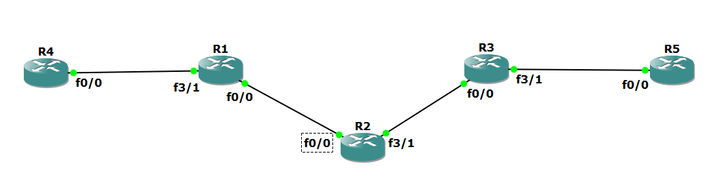

R1

conf t

hostname R1

int lo0

ip add 1.1.1.1 255.255.255.255

ip ospf 1 area 0

int f0/0

ip add 10.0.0.1 255.255.255.0

no shut

ip ospf 1 area 0

R2

hostname R2

int lo0

ip add 2.2.2.2 255.255.255.255

ip ospf 1 are 0

int f0/0

ip add 10.0.0.2 255.255.255.0

no shut

ip ospf 1 area 0

int f3/1

ip add 10.0.1.2 255.255.255.0

no shut

ip ospf 1 area 0

R3

hostname R3

int lo0

ip add 3.3.3.3 255.255.255.255

ip ospf 1 are 0

int f0/0

ip add 10.0.1.3 255.255.255.0

no shut

ip ospf 1 area 0

R1# ping 3.3.3.3 source lo0

R1

conf t

router ospf 1

mpls ldp autoconfig

R2

conf t

router ospf 1

mpls ldp autoconfig

R3

conf t

router ospf 1

mpls ldp autoconfig

R2# sh mpls interface

R2#sh mpls ldp neigh

R1#trace 3.3.3.3

R1#

conf t

router bgp 1

neighbor 3.3.3.3 remote-as 1

neighbor 3.3.3.3 update-source Loopback0

no auto-summary

!

address-family vpnv4

neighbor 3.3.3.3 activate

R3#

conf t

router bgp 1

neighbor 1.1.1.1 remote-as 1

neighbor 1.1.1.1 update-source Loopback0

no auto-summary

!

address-family vpnv4

neighbor 1.1.1.1 activate

R1# sh bgp vpnv4 unicast all summary

R4

int lo0

ip add 4.4.4.4 255.255.255.255

ip ospf 2 area 2

int f0/0

ip add 192.168.1.4 255.255.255.0

ip ospf 2 area 2

no shut

R1

conf t

int f3/1

no shut

ip add 192.168.1.1 255.255.255.0

R1

conf t

ip vrf RED

rd 4:4

route-target both 4:4

R1

conf t

int f3/1

ip vrf forwarding RED

R1(config-if)# ip vrf fo

R1(config-if)# ip vrf forwarding RED

R1

conf t

int f3/1

ip address 192.168.1.1 255.255.255.0

R1# sh run int f3/1

R1# sh ip route

R1# sh ip route vrf red

R1# sh ip route vrf RED

R1

conf t

int f3/1

ip ospf 2 area 2

R1# sh ip route vrf RED

R5

conf t

int lo0

ip add 6.6.6.6 255.255.255.255

ip ospf 2 area 2

int f0/0

ip add 192.168.2.6 255.255.255.0

ip ospf 2 area 2

no shut

R3

conf t

int f3/1

no shut

ip add 192.168.2.3 255.255.255.0

R3

conf t

ip vrf RED

rd 4:4

route-target both 4:4

R3

conf t

int f3/1

ip vrf forwarding RED

R3(config-if)#ip vrf forwarding RED

R3

conf t

int f3/1

ip address 192.168.2.1 255.255.255.0

R3# sh run int f3/1

R3

conf t

int f3/1

ip ospf 2 area 2

R3# sh ip route vrf RED

R4# sh ip route

R1# sh ip route

R1# sh ip route vrf RED

R1

conf t

router bgp 1

address-family ipv4 vrf RED

redistribute ospf 2

R3

conf t

router bgp 1

address-family ipv4 vrf RED

redistribute ospf 2

R1# sh ip bgp vpnv4 vrf RED

R3# sh ip bgp vpnv4 vrf RED

R1

conf t

router ospf 2

redistribute bgp 1 subnets

R3

conf t

router ospf 2

redistribute bgp 1 subnets

R4# sh ip route

R5# sh ip route

R4# ping 6.6.6.6

R4# trace 6.6.6.6